* Name**: Anda Xie**
* Picture:

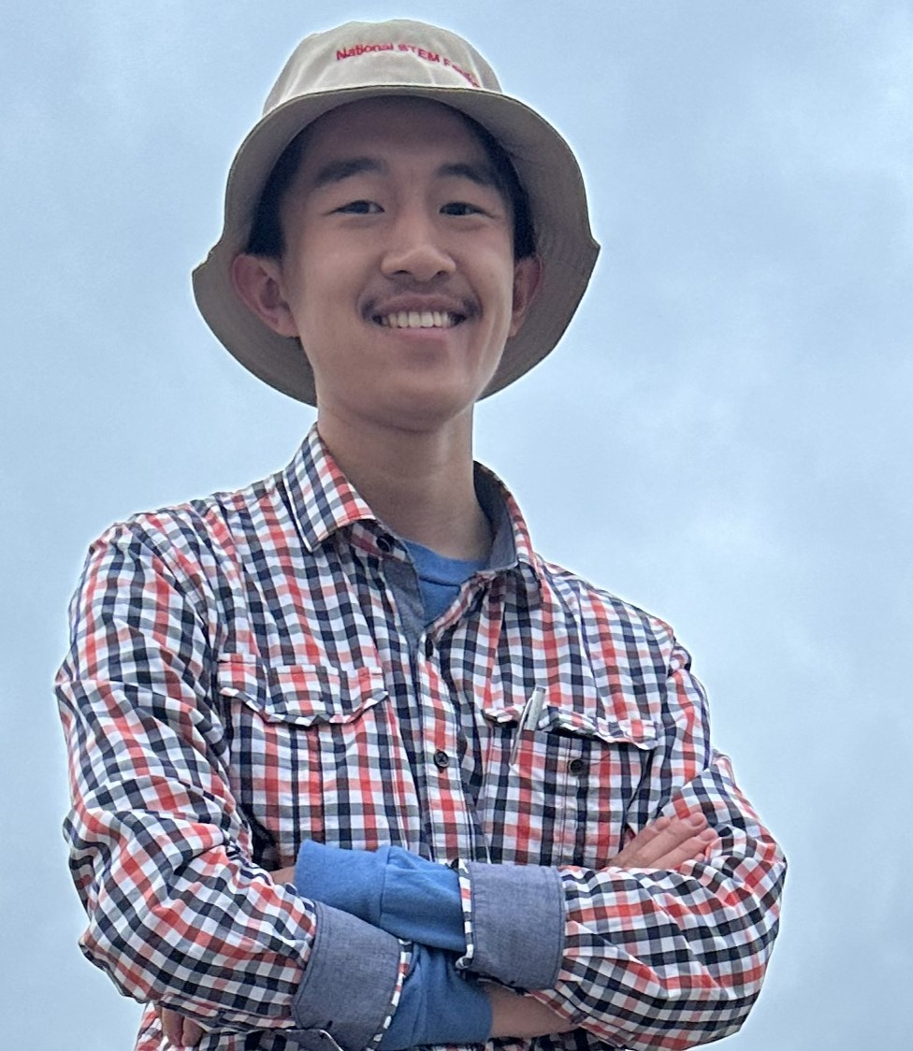

* Degreeand Department: High School Lab Intern in Electrical Engineering**.**
* About**:** I am a High School Junior at West High School volunteering as an intern at the Kahlert School of Computing at the University of Utah. In the summer of 2024, I worked in Professor Daniel Brown’s research laboratory assisting in the construction of swarm robots for research in emergent behavior as well as the operation of a ROS control system. I am interested in both software and hardware development. I plan to pursue an undergraduate degree in EE at a research focused university before graduate school.
* Links**:**
* <https://github.com/SussyTestAccount>